Micrometer
# Source: AI Source: Provided by: [Data Path: Persons Table -> ID Column: 1, Name_En Column: Motasem Essam] -> From: [ChatGPT] on [7/17/2026]
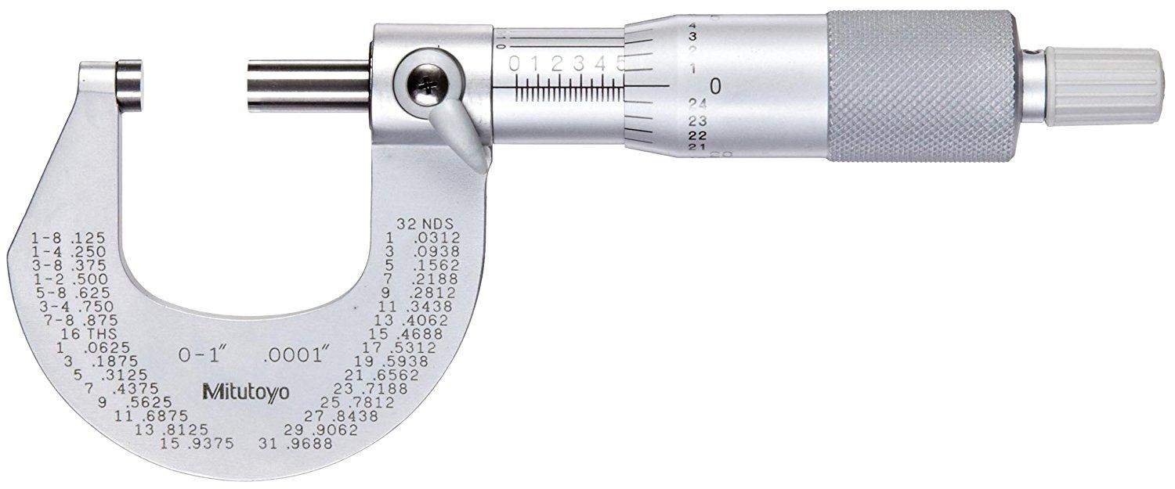
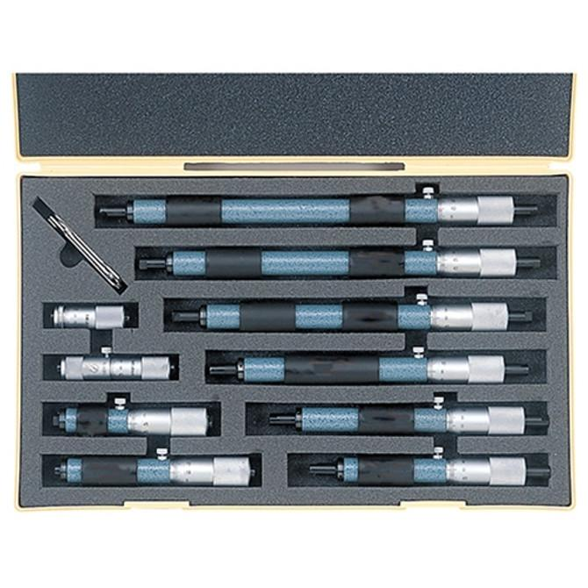
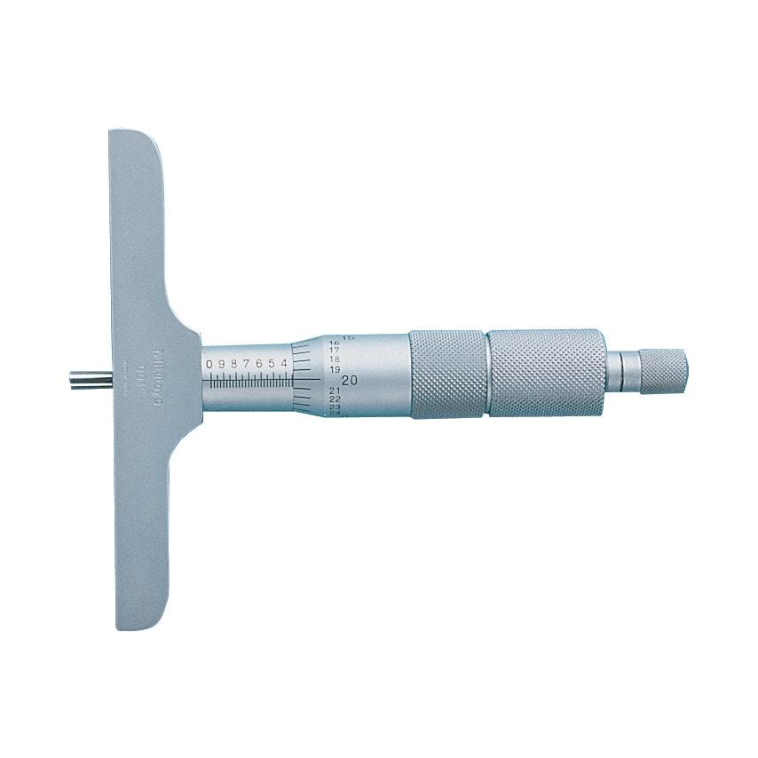
A Micrometer (also called a Micrometer Screw Gauge) is a high-precision measuring instrument used to measure very small linear dimensions with much greater accuracy than a Vernier caliper. It operates using a precision screw mechanism, where the rotational movement of the thimble is converted into a highly accurate linear movement of the spindle.
Micrometers are widely used in mechanical engineering, manufacturing, machining, metrology, quality control, automotive, aerospace, and scientific laboratories.

Definition
# Source: AI Source: Provided by: [Data Path: Persons Table -> ID Column: 1, Name_En Column: Motasem Essam] -> From: [ChatGPT] on [7/17/2026]
A Micrometer is a precision measuring instrument that uses a calibrated screw mechanism to accurately measure small external, internal, or depth dimensions.

Purpose
# Source: AI Source: Provided by: [Data Path: Persons Table -> ID Column: 1, Name_En Column: Motasem Essam] -> From: [ChatGPT] on [7/17/2026]
A Micrometer is used to:
- Measure thickness.
- Measure outside diameter.
- Measure inside diameter.
- Measure depth.
- Measure wire diameter.
- Measure sheet thickness.
- Perform high-precision dimensional inspection.

Principle of Operation
# Source: AI Source: Provided by: [Data Path: Persons Table -> ID Column: 1, Name_En Column: Motasem Essam] -> From: [ChatGPT] on [7/17/2026]
A micrometer works on the screw principle:
- Rotating the thimble moves the spindle toward or away from the anvil.
- The screw has a known pitch, so each rotation corresponds to a precise linear movement.
- The measurement is read from the sleeve scale and the thimble scale.

Main Components
# Source: AI Source: Provided by: [Data Path: Persons Table -> ID Column: 1, Name_En Column: Motasem Essam] -> From: [ChatGPT] on [7/17/2026]
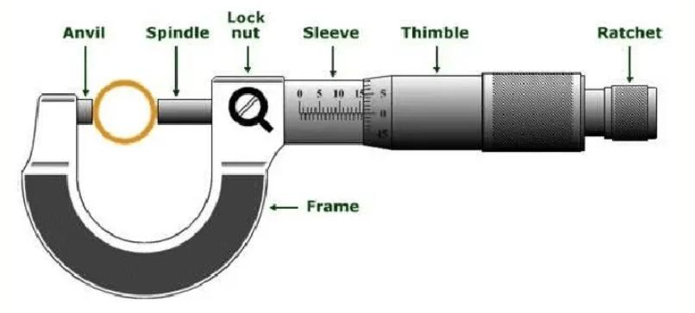
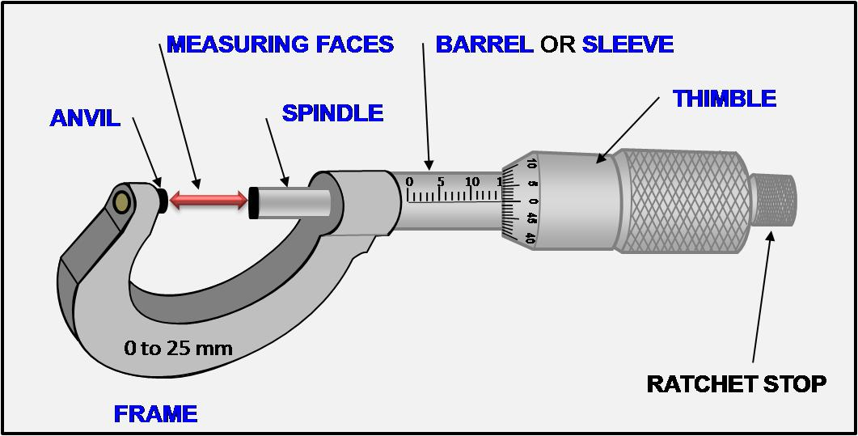
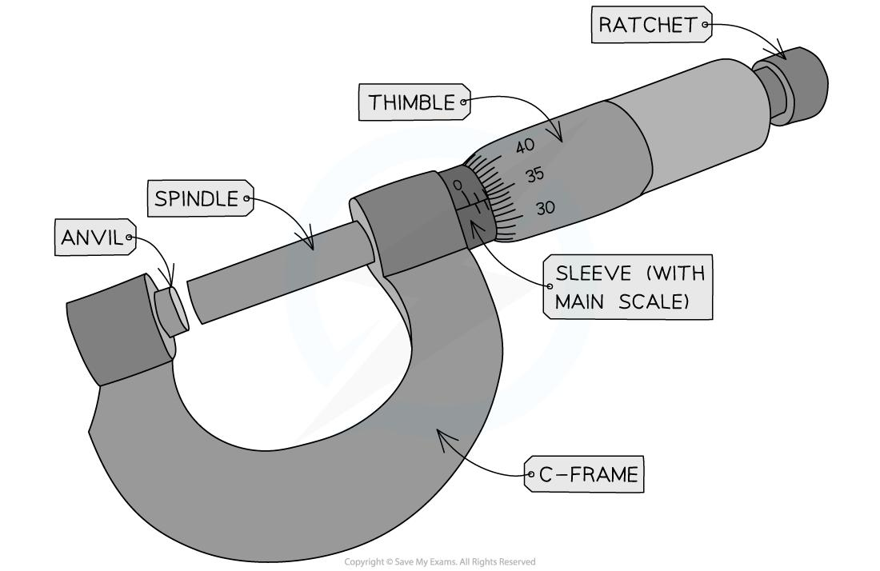
A typical micrometer consists of:
- Frame
- Anvil (fixed measuring face)
- Spindle (movable measuring face)
- Sleeve (main scale)
- Thimble (rotating scale)
- Ratchet Stop
- Lock Nut / Lock Lever
- Measuring Faces

Types of Micrometers

1. Outside Micrometer
# Source: AI Source: Provided by: [Data Path: Persons Table -> ID Column: 1, Name_En Column: Motasem Essam] -> From: [ChatGPT] on [7/17/2026]
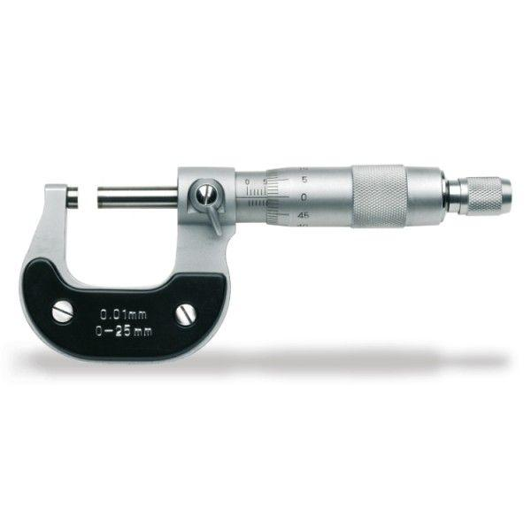
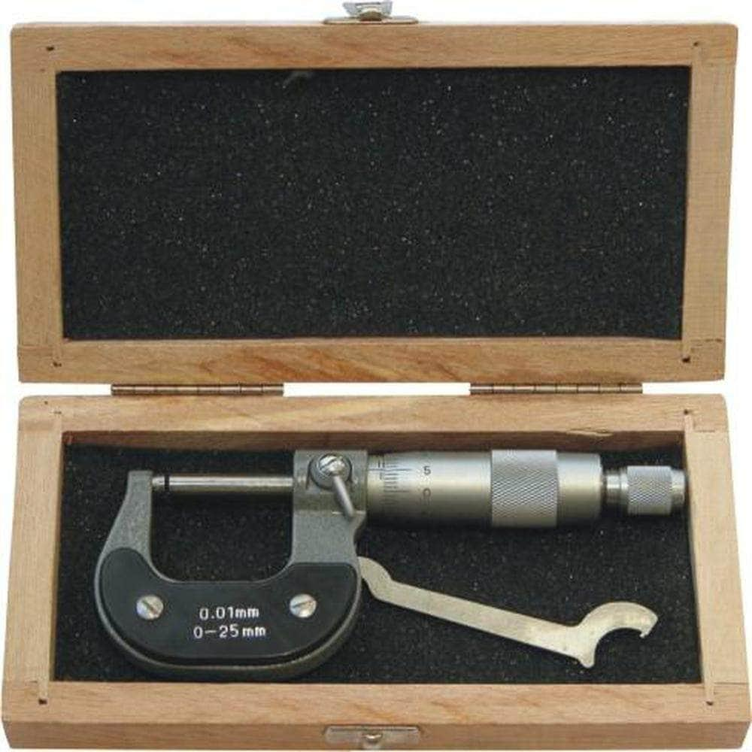
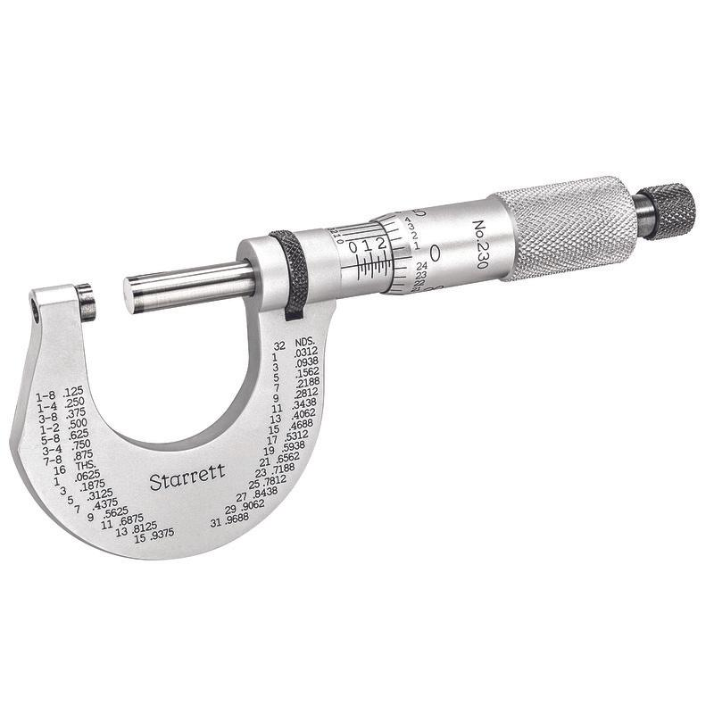
Description
Measures external dimensions such as thickness, outside diameter, and width.
Applications
- Shaft diameter
- Wire thickness
- Metal sheet thickness
- Small machined parts

2. Inside Micrometer
# Source: AI Source: Provided by: [Data Path: Persons Table -> ID Column: 1, Name_En Column: Motasem Essam] -> From: [ChatGPT] on [7/17/2026]
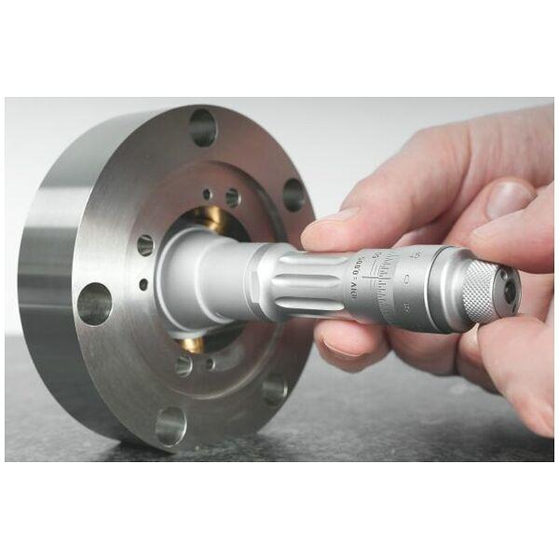
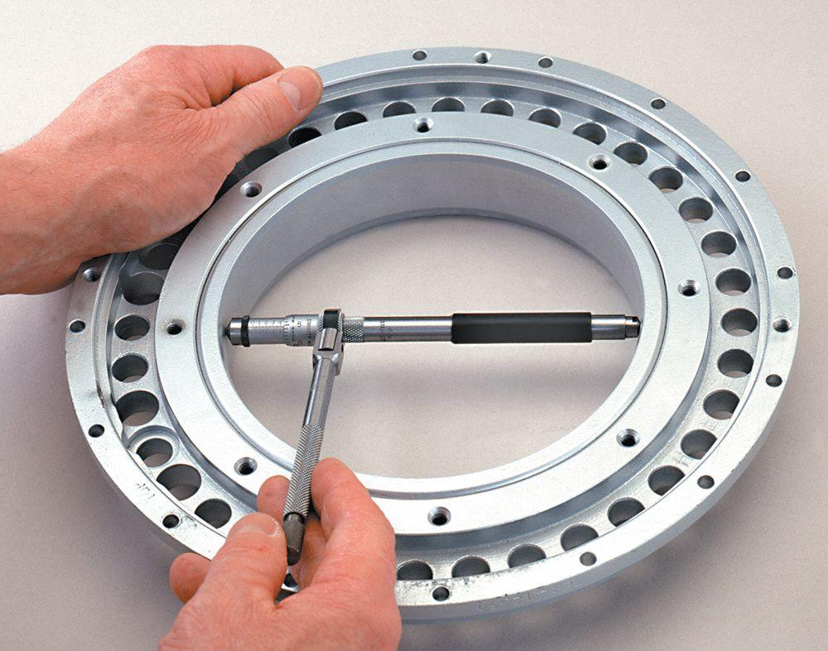
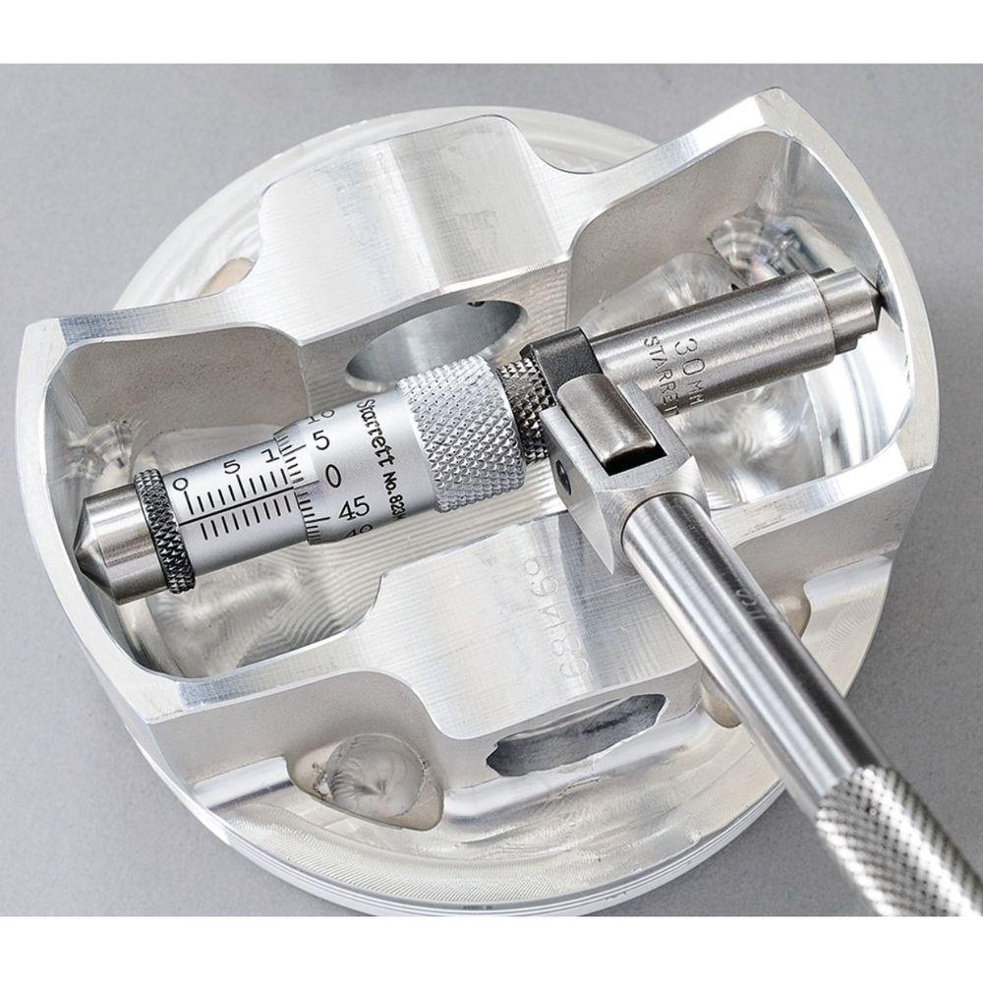
Description
Measures internal diameters of holes, cylinders, and bores.
Applications
- Pipe diameters
- Bore inspection
- Internal dimensions

3. Depth Micrometer
# Source: AI Source: Provided by: [Data Path: Persons Table -> ID Column: 1, Name_En Column: Motasem Essam] -> From: [ChatGPT] on [7/17/2026]
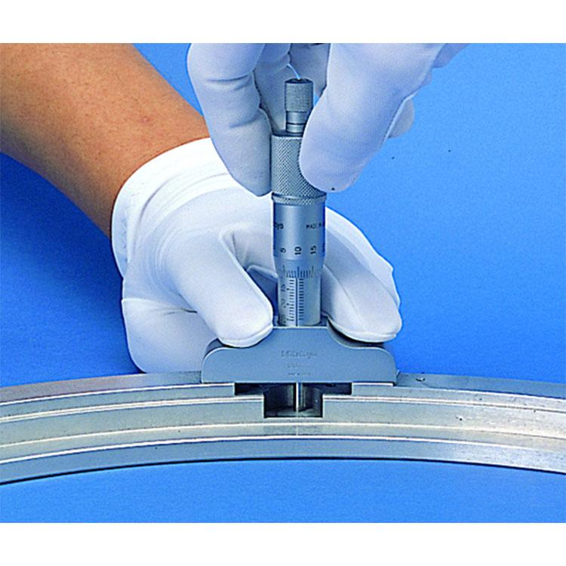
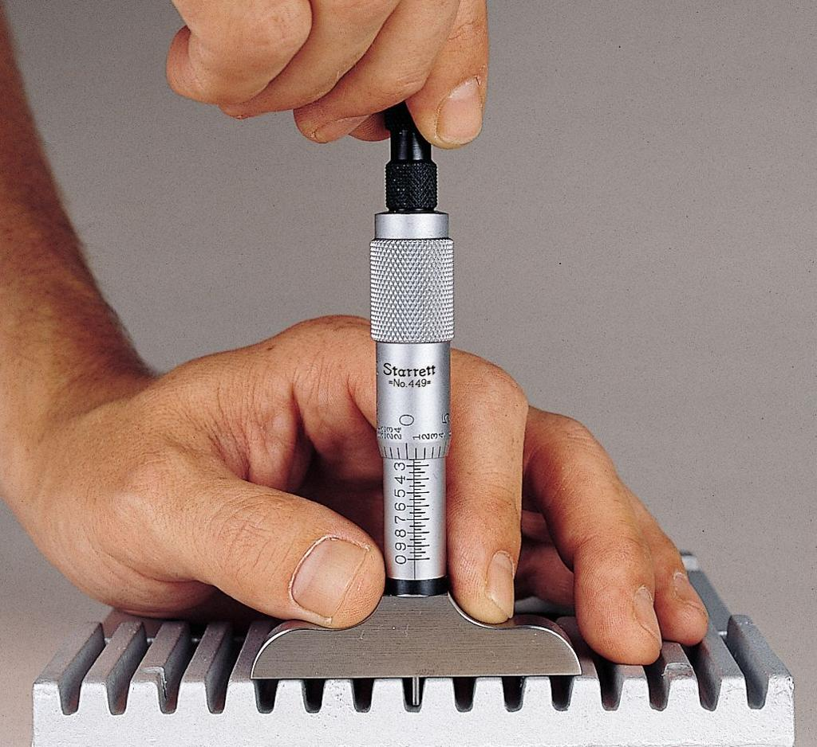
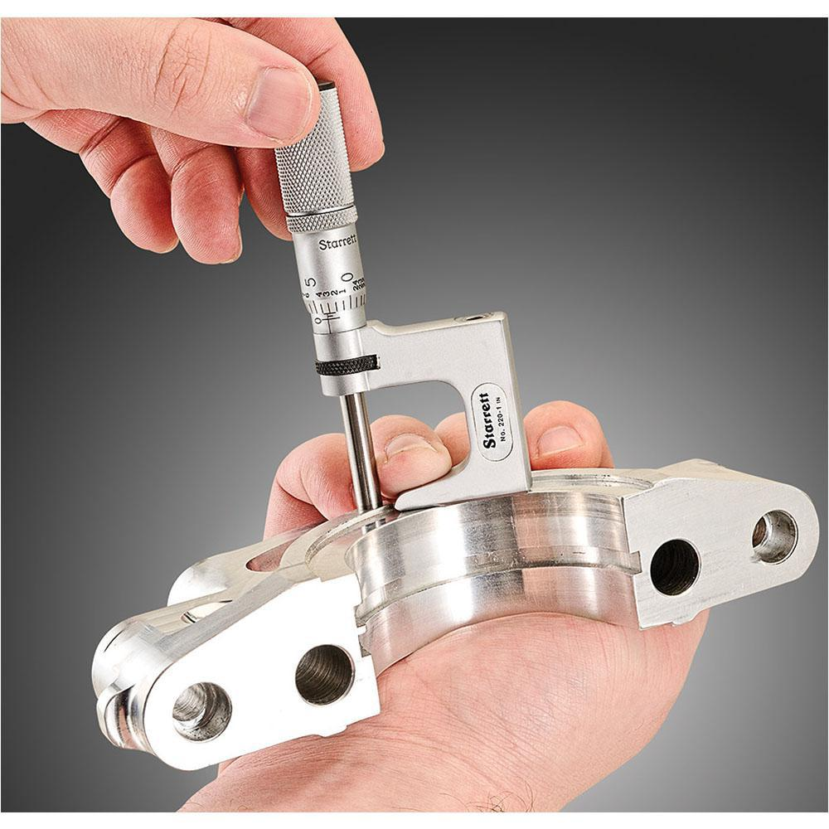
Description
Measures the depth of holes, slots, recesses, and grooves.
Applications
- Hole depth
- Slot depth
- Recess measurements

4. Digital Micrometer
# Source: AI Source: Provided by: [Data Path: Persons Table -> ID Column: 1, Name_En Column: Motasem Essam] -> From: [ChatGPT] on [7/17/2026]
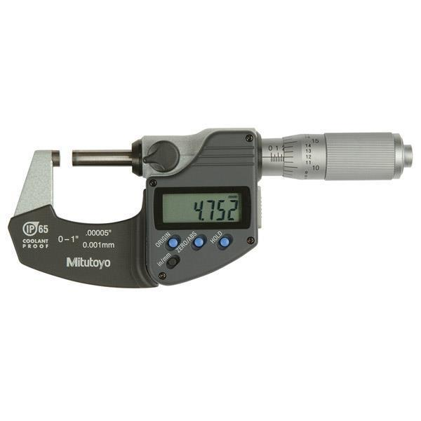
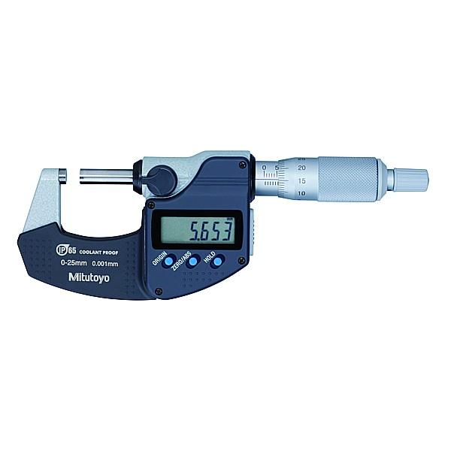
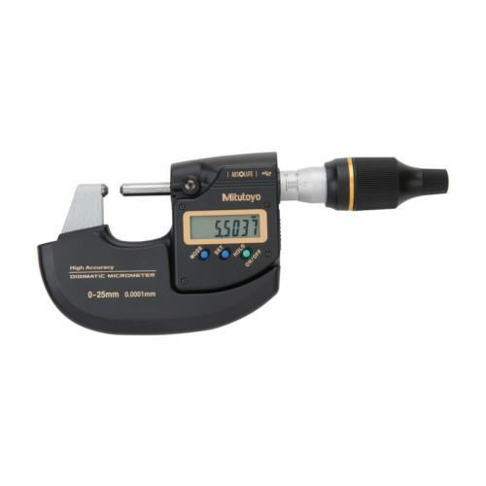
Description
Uses an electronic sensor and LCD display to provide direct digital readings.
Features
- Metric/Imperial conversion
- Zero setting
- Battery powered
- Easy reading

Measuring Range
# Source: AI Source: Provided by: [Data Path: Persons Table -> ID Column: 1, Name_En Column: Motasem Essam] -> From: [ChatGPT] on [7/17/2026]
Micrometers are available in fixed ranges.
Common ranges include:
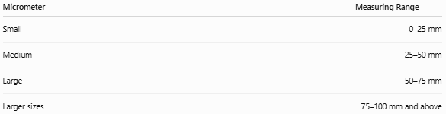
Micrometer | Measuring Range
Small | 0–25 mm
Medium | 25–50 mm
Large | 50–75 mm
Larger sizes | 75–100 mm and above

Least Count (Resolution)
# Source: AI Source: Provided by: [Data Path: Persons Table -> ID Column: 1, Name_En Column: Motasem Essam] -> From: [ChatGPT] on [7/17/2026]
Typical least counts:
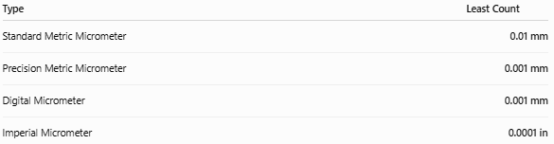
Type | Least Count
Standard Metric Micrometer | 0.01 mm
Precision Metric Micrometer | 0.001 mm
Digital Micrometer | 0.001 mm
Imperial Micrometer | 0.0001 in

How to Measure with a Micrometer
# Source: AI Source: Provided by: [Data Path: Persons Table -> ID Column: 1, Name_En Column: Motasem Essam] -> From: [ChatGPT] on [7/17/2026]
- Clean the measuring faces.
- Place the object between the anvil and spindle.
- Rotate the thimble until the spindle contacts the object.
- Use the ratchet stop to apply consistent measuring force.
- Read the sleeve scale.
- Read the thimble scale.
- Add the readings together.
- Record the measurement with the correct unit.

Example
# Source: AI Source: Provided by: [Data Path: Persons Table -> ID Column: 1, Name_En Column: Motasem Essam] -> From: [ChatGPT] on [7/17/2026]
Suppose:
- Sleeve Reading = 7.5 mm
- Thimble Reading = 0.28 mm
Final Measurement:
Measured value = 7.78 mm

Accuracy
# Source: AI Source: Provided by: [Data Path: Persons Table -> ID Column: 1, Name_En Column: Motasem Essam] -> From: [ChatGPT] on [7/17/2026]
Typical accuracy:
- ±0.01 mm
- ±0.002 mm
- ±0.001 mm (high-precision models)
Accuracy depends on:
- Calibration
- Clean measuring faces
- Proper ratchet use
- Temperature stability

Sources of Error
# Source: AI Source: Provided by: [Data Path: Persons Table -> ID Column: 1, Name_En Column: Motasem Essam] -> From: [ChatGPT] on [7/17/2026]
Instrument Errors
- Calibration error
- Worn spindle or anvil
- Damaged screw threads
- Zero error

Observation Errors
- Incorrect scale reading (analog models)
- Recording mistakes

Positioning Errors
- Misaligned workpiece
- Dirt between measuring faces
- Excessive measuring force

Environmental Errors
- Thermal expansion
- Dust
- Moisture
- Vibration

Applications
# Source: AI Source: Provided by: [Data Path: Persons Table -> ID Column: 1, Name_En Column: Motasem Essam] -> From: [ChatGPT] on [7/17/2026]
Micrometers are used in:
- Mechanical engineering
- Precision machining
- Manufacturing
- Quality control
- Metrology
- Aerospace
- Automotive
- Tool making
- Scientific laboratories

Advantages
# Source: AI Source: Provided by: [Data Path: Persons Table -> ID Column: 1, Name_En Column: Motasem Essam] -> From: [ChatGPT] on [7/17/2026]
A Micrometer:
- Provides extremely high precision.
- Produces repeatable measurements.
- Is suitable for very small dimensions.
- Is available for outside, inside, and depth measurements.
- Is more accurate than a Vernier caliper.

Limitations
# Source: AI Source: Provided by: [Data Path: Persons Table -> ID Column: 1, Name_En Column: Motasem Essam] -> From: [ChatGPT] on [7/17/2026]
A Micrometer:
- Measures a limited size range.
- Is slower than a Vernier caliper.
- Requires careful handling.
- Needs periodic calibration.
- Cannot measure large objects with a single instrument.

Comparison with Other Length Measuring Instruments
# Source: AI Source: Provided by: [Data Path: Persons Table -> ID Column: 1, Name_En Column: Motasem Essam] -> From: [ChatGPT] on [7/17/2026]
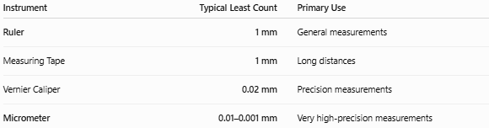
Instrument | Typical Least Count | Primary Use
Ruler | 1 mm | General measurements
Measuring Tape | 1 mm | Long distances
Vernier Caliper | 0.02 mm | Precision measurements
Micrometer | 0.01–0.001 mm | Very high-precision measurements

Care and Maintenance
# Source: AI Source: Provided by: [Data Path: Persons Table -> ID Column: 1, Name_En Column: Motasem Essam] -> From: [ChatGPT] on [7/17/2026]
To maintain accuracy:
- Keep measuring faces clean.
- Avoid dropping the instrument.
- Store in a protective case.
- Use the ratchet stop rather than excessive force.
- Check for zero error before use.
- Calibrate regularly.

Common Mistakes
# Source: AI Source: Provided by: [Data Path: Persons Table -> ID Column: 1, Name_En Column: Motasem Essam] -> From: [ChatGPT] on [7/17/2026]
- Applying excessive pressure.
- Ignoring zero error.
- Measuring dirty surfaces.
- Reading the wrong scale.
- Not using the ratchet stop.
- Measuring objects outside the instrument's range.

Key Points
# Source: AI Source: Provided by: [Data Path: Persons Table -> ID Column: 1, Name_En Column: Motasem Essam] -> From: [ChatGPT] on [7/17/2026]
- A Micrometer is a high-precision measuring instrument.
- It uses a precision screw mechanism.
- It measures:
  - External dimensions
  - Internal dimensions
  - Depths
- Typical least count:
  - 0.01 mm
  - 0.001 mm (precision models)
- It is one of the most accurate manual measuring instruments used in engineering and manufacturing.

Conclusion
# Source: AI Source: Provided by: [Data Path: Persons Table -> ID Column: 1, Name_En Column: Motasem Essam] -> From: [ChatGPT] on [7/17/2026]
A Micrometer is one of the most accurate manual instruments for measuring small linear dimensions. By employing a finely threaded screw mechanism, it provides measurements with resolutions commonly ranging from 0.01 mm to 0.001 mm, making it significantly more precise than a Vernier caliper. Available in outside, inside, depth, and digital versions, the micrometer is indispensable in precision engineering, machining, manufacturing, metrology, and quality control, where accurate dimensional inspection is critical.

